**ASSIGNMENT I**

1) Name different modes of python.

* Script mode
* Interactive mode

2) Explain Local and Global variable.

* Local variables in Python are those which are initialized inside a function and belong only to that particular function.
* Global variables are those which are defined outside any function and are accessible throughout the program.

3) How to give single and multiline comment in python.

* To add a single line comment, we use the hash (# comment).
* To add a multiline comment, use triple quotation marks (“”” comment “””).

4) List Data types used in python. Explain any two with example.

The data types used in Python are:

* int
* float
* complex
* string
* Boolean
* list
* tuple
* dictionary
* set

To explain any two as follows:

1. Boolean

* Booleans consist of only two values, True or False. There cannot be any value other than True or False. Booleans are useful for applying conditional operations.

1. int

* Integer data types are numeric data types. They hold whole numbers which can positive, negative, or zero without a fractional part and have unlimited precision.

5) Explain building blocks of python.

* Identifiers: Identifiers are names given to different parts of the program such as variables, objects, classes, functions, lists, dictionaries, etc. They are unlimited in length.
* Keywords: Keywords are reserved words that have pre-defined meanings in the Python language. There are 33 keywords in Python.
* Operators: Operators are used to perform operations on variables and data types. There are 45 operators in Python.
* Control Structures: Control structures are used to control the flow of a program. Python has three control structures, conditional statements, loops and functions.
* Data Types: Data types define the type of data that can be stored in a variable. Python has several built-in data types.
* Functions: Functions are reusable pieces of code that can be called by other parts of a program.

6) List Python features. (Any eight)

* High-level language
* Easy to code
* Large community support
* Free and Open Source
* Object Oriented Language
* Easy to read
* Dynamically Typed Language

7) Describe indentation in Python.

* It refers to the use of spaces at the beginning of a line of code to define the scope of statements, such as those within loops, conditionals, functions, and classes.
* Python uses whitespace indentation to define code blocks instead of using curly braces or keywords.
* Python's default indentation is four spaces. However, you can use any number of spaces as long as you are consistent throughout your code.
* It is important to note that Python does not allow mixing tabs and spaces for indentation. This can lead to errors.

8) What is local and global variables?

* Local variables in Python are those which are initialized inside a function and belong only to that particular function. It cannot be accessed anywhere outside the function.
* Global variables are those which are defined outside any function and are accessible throughout the program, i.e., inside and outside of every function.  
  **Example:**  
  x = 5  
  print(x, ", x is a global variable")  
  def showLocal():  
   y = 10  
   print(y, ", y is a local variable")  
  showLocal()  
  print(y)

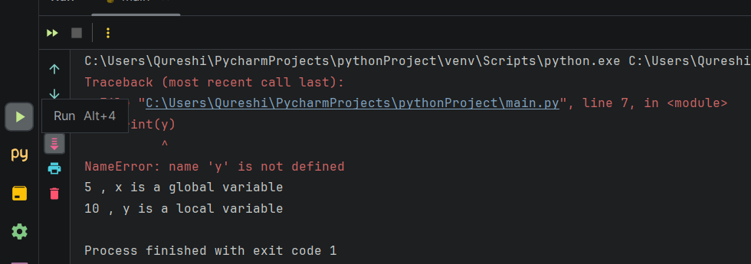

9)What is command line argument? Write python code to add two numbers given as input from command line arguments and print its sum.

* The arguments that are given after the name of the program in the command line shell of the operating system are known as Command Line Arguments.
* To add two numbers from command line arguments:

Code:  
import sys  
n = len(sys.argv)  
Sum = 0  
for i in range(1, n):  
 Sum += int(sys.argv[i])  
print("Sum: ", Sum)

**Output:**  


10) Write different data types in python with suitable example.

* int
* float
* complex
* string
* boolean
* list
* tuple
* dictionary
* set

**Example code:**

a = 347  
print(a)  
print(type(a))  
a = "EXO"  
print(a)  
print(type(a))  
a = 34j  
print(a)  
print(type(a))  
a = True  
print(a)  
print(type(a))  
a = 3.47  
print(a)  
print(type(a))  
aList = ["EXO", 347, True, 34.7, 47j]  
print(aList)  
print(type(aList))  
aDict = {"Name" : "EXO"}  
print(aDict)  
print(type(aDict))  
willBeTuple = 3, 4, 7, "E", "X", "O"  
print(willBeTuple)  
print(type(willBeTuple))  
aSet = {3, 4, 7, "EXO"}  
print(aSet)  
print(type(aSet))

**Output:**  
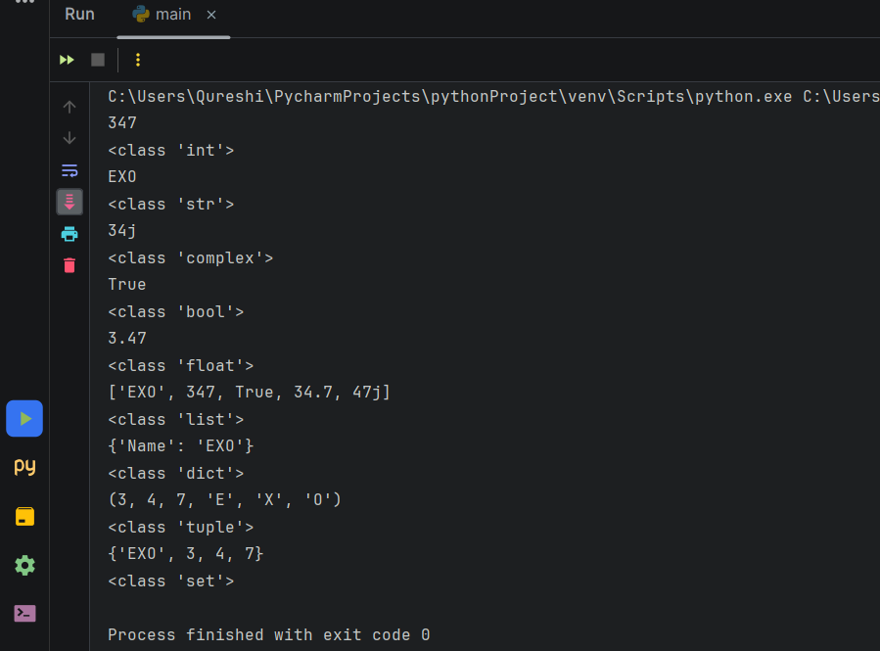

11) Explain mutable and immutable data structures.

* Mutable objects in Python are those that can be changed after they are created, like lists or dictionaries.
* Immutable objects, on the other hand, cannot be changed after they are created, such as strings, integers, or tuples.
* You can change the value of mutable objects using the assignment operator.
* On the other hand, if you attempt to change an immutable object using the assignment operator, a new instance will be created that will hold the new value.

12) Describe multiline comment in Python.

* You can create a multiline comment using triple quotation marks (“””). These are used to write comments over multiple lines.  
  """

This is a multiline comment

that spans multiple lines.

It serves to document the purpose

of the following code block.

The code below calculates the sum

of the elements in a list.

"""

# Define a list of numbers

numbers = [1, 2, 3, 4, 5]

# Calculate the sum of the numbers

total = sum(numbers)

# Print the result

print("The sum of the numbers is:", total)

13) Describe ‘continue’ keyword with example.

* The ‘continue’ keyword is used to skip the remaining code to be executed in the given iteration of the loop, and start with the next iteration of the loop.
* The code after continue will not be executed if the keyword is encountered.

**Example code:**  
for i in range(1, 11):  
 if i % 2 != 0:  
 continue # The iteration will be skipped in the event of an odd number  
 print(i, end=" ")

Output:  
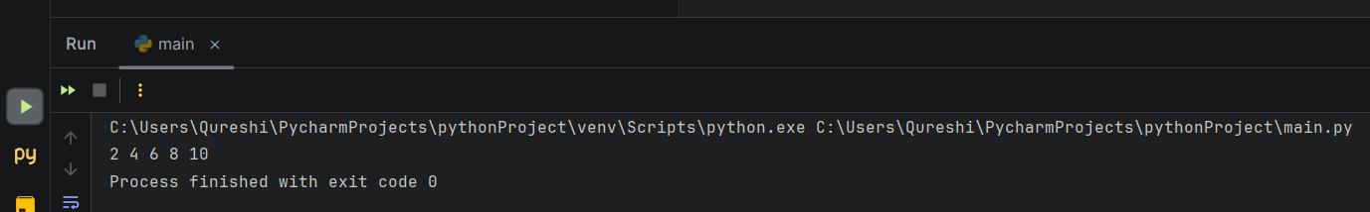

**14) Write a Python program to display “MSBTE” using Script Mode**

**CODE:**

print("MSBTE")

**OUTPUT:**

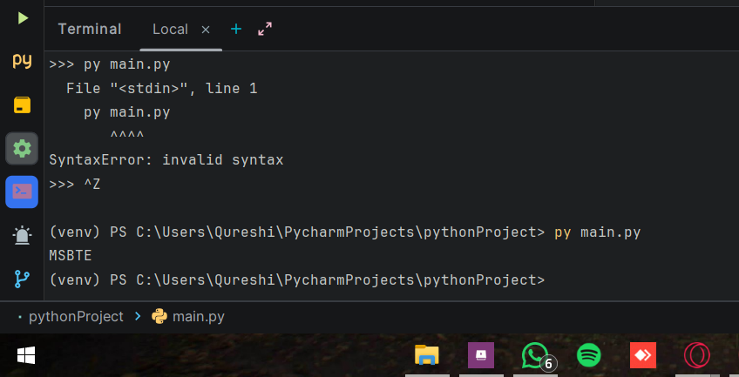

**15) Write a Program to calculate simple interest**

**CODE:**

principle_amount = int(input("Enter Principal Amount: "))  
rate_of_interest = int(input("Enter Rate Of Interest: "))  
time_period = int(input("Enter Time Period: "))  
  
grand_total_amount = (principle_amount * rate_of_interest * time_period) / 100  
  
print("Grand Total: " , grand_total_amount)

**OUTPUT:**

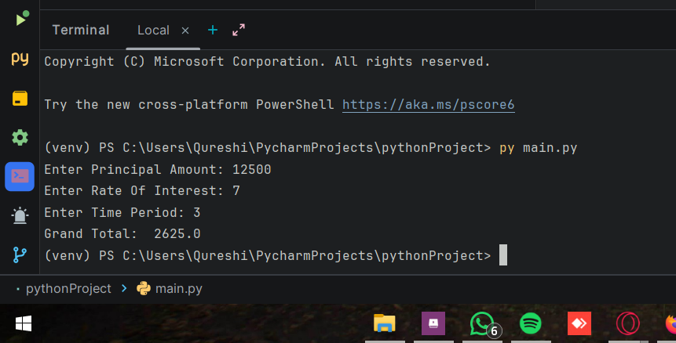

16) Program to calculate Compound interest.

**Code:**  
principal = float(input("Enter principal value: "))  
rate = float(input("Enter rate of interest: "))  
time = float(input("Enter time period: "))  
compoundInterest = principal * (1 + rate / 100) ** time – principal  
print("Compound interest: ", compoundInterest)  
print("Final amount: ", principal + compoundInterest)

**Output:**  
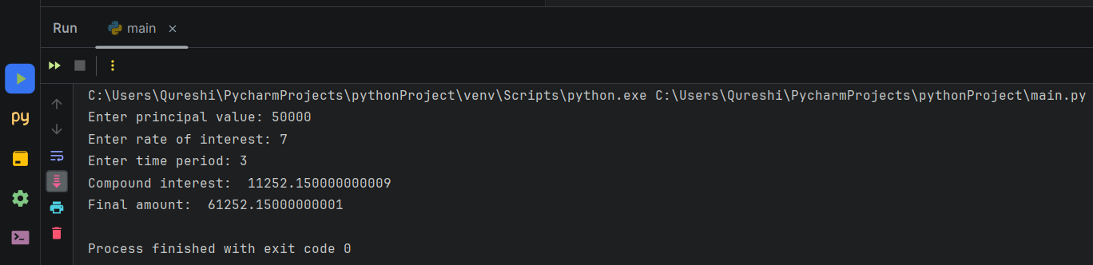

17) Convert U.S. Dollars to Indian Rupees.

Code:

usd = float(input("Enter your amount in USD: "))  
inr = usd * 83.12  
print(usd, " USD => ", inr, " INR")

Output:

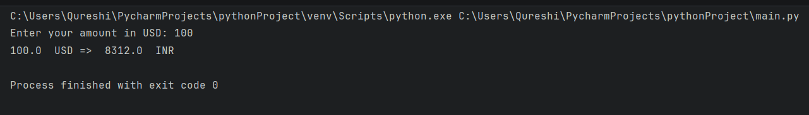

18) Convert bits to Megabytes, Gigabytes and Terabytes.

Code:

bits = float(input("Enter the number of bits: "))  
byte = bits / 8  
kiloBytes = byte / 1024  
megaBytes = kiloBytes / 1024  
gigaBytes = megaBytes / 1024  
teraBytes = gigaBytes / 1024  
print(bits, " bits in Megabytes: ", megaBytes)  
print(bits, " bits in Gigabytes: ", gigaBytes)  
print(bits, " bits in Terabytes: ", teraBytes)

Output:

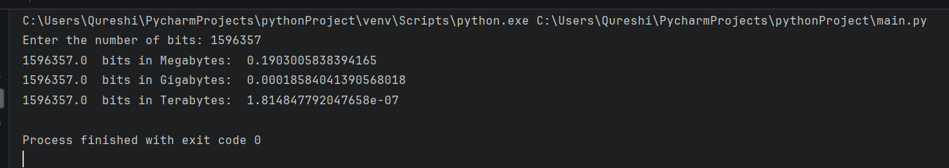

19) Find square root of a number.

Code:

inputNum = float(input("Enter a number: "))  
print("The square root of ", inputNum, " is ", inputNum ** 0.5)

Output:

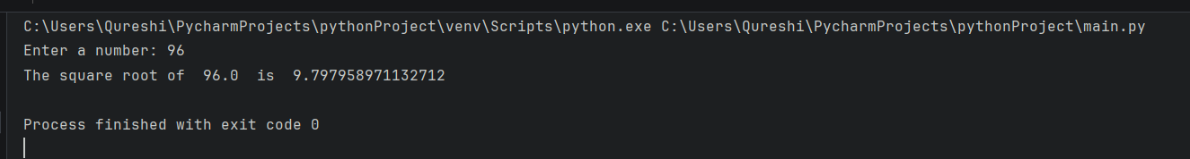

20) Find area of a rectangle.

Code:

length = float(input("Enter the length of a rectangle: "))  
breadth = float(input("Enter the breadth of a rectangle: "))  
area = length * breadth  
print("The area of the rectangle is: ", area, "square units.")

Output:

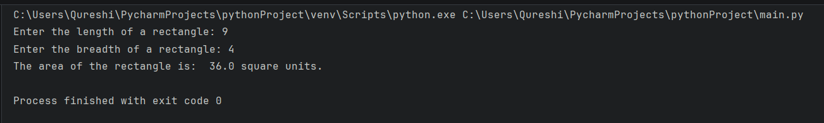

21) Calculate area and perimeter of a square.

Code:

side = float(input("Enter the length of the side of a square: "))  
perimeter = 4 * side  
area = side * side  
print("The area of the square is: ", area, "square units.")  
print("The perimeter of the square is: ", perimeter, "square units.")

Output:

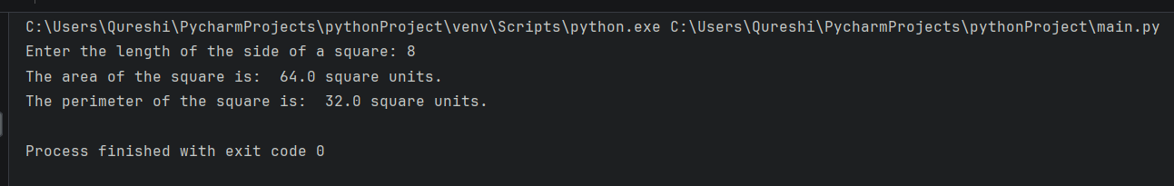

22) Surface area and volume of a cylinder.

Code:

radius = float(input("Enter the radius of a cylinder: "))  
height = float(input("Enter the height of a cylinder: "))  
surfaceArea = 2 * 3.14 * radius * height + 2 * 3.14 * radius * radius  
volume = 3.14 * radius * radius * height  
print("The surface area of the cylinder is: ", surfaceArea, "square units.")  
print("The volume of the cylinder is: ", volume, "square units.")

Output:

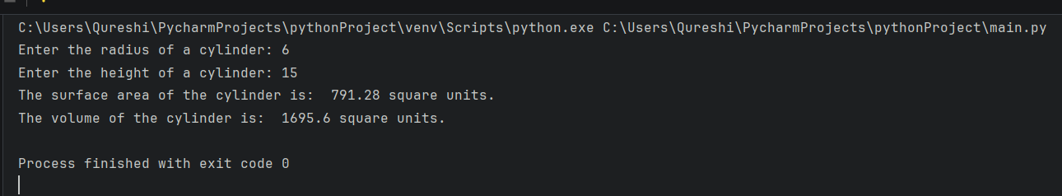

23) Swap the value of two variables.

Code:

a = int(input("Enter a number: "))  
b = int(input("Enter another number: "))  
print("Before swap: a = ", a, ", b = ", b)  
temp = a  
a = b   
b = temp  
print("After swap: a = ", a, ", b = ", b)

Output:

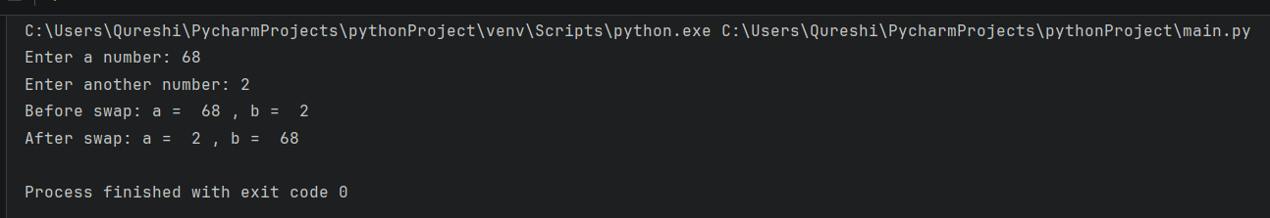

24) Solve quadratic equations.

Code:

a = float(input("Enter the coefficient a: "))  
b = float(input("Enter the coefficient b: "))  
c = float(input("Enter the coefficient c: "))  
print("Generated quadratic equation:\n", a, "x^2 + ", b, "x + ", c, " = 0")  
discriminant = b ** 2 - 4 * a * c  
if discriminant >= 0:  
 root_1 = (-b + discriminant ** 0.5) / (2 * a)  
 root_2 = (-b - discriminant ** 0.5) / (2 * a)  
 print("Roots of the quadratic equation are:\nRoot 1: ", root_1, "Root 2: ", root_2)  
else:  
 print("The roots of this quadratic equation are not real. BRUH?")

Output:

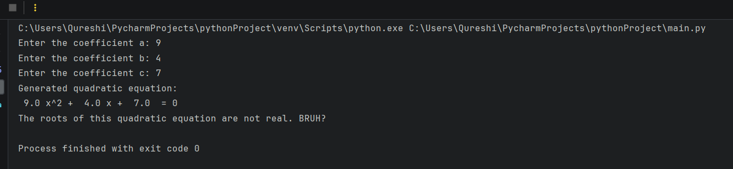

25) Print current date and time.

Code:

import datetime

currentTime = datetime.datetime.now()

print(currentTime.strftime("%Y-%m-%d %H:%M:%S"))

Output:

